1)Python program using OpenCV library and perform the following with respect to an image.

a) Read a gray scale image and display.

b) Increase and decrease the brightness and save it in a drive.

c) Split the image into three channel(R,G,B).

d) Resize the image by shrinking and zooming the same by using interpolation method.

e) Rotate the image to about 60 degree without scaling.

f) Demonstrate edge detection of your image with suitable algorithm.

RegNo:2117104

Date: 11-08-2022

a)

import cv2

img = cv2.imread(r"D:\IP\images\paris.jpg",cv2.IMREAD_GRAYSCALE)

cv2.imshow('image',img)

cv2.waitKey(0)

cv2.destroyAllWindows()

OUTPUT:

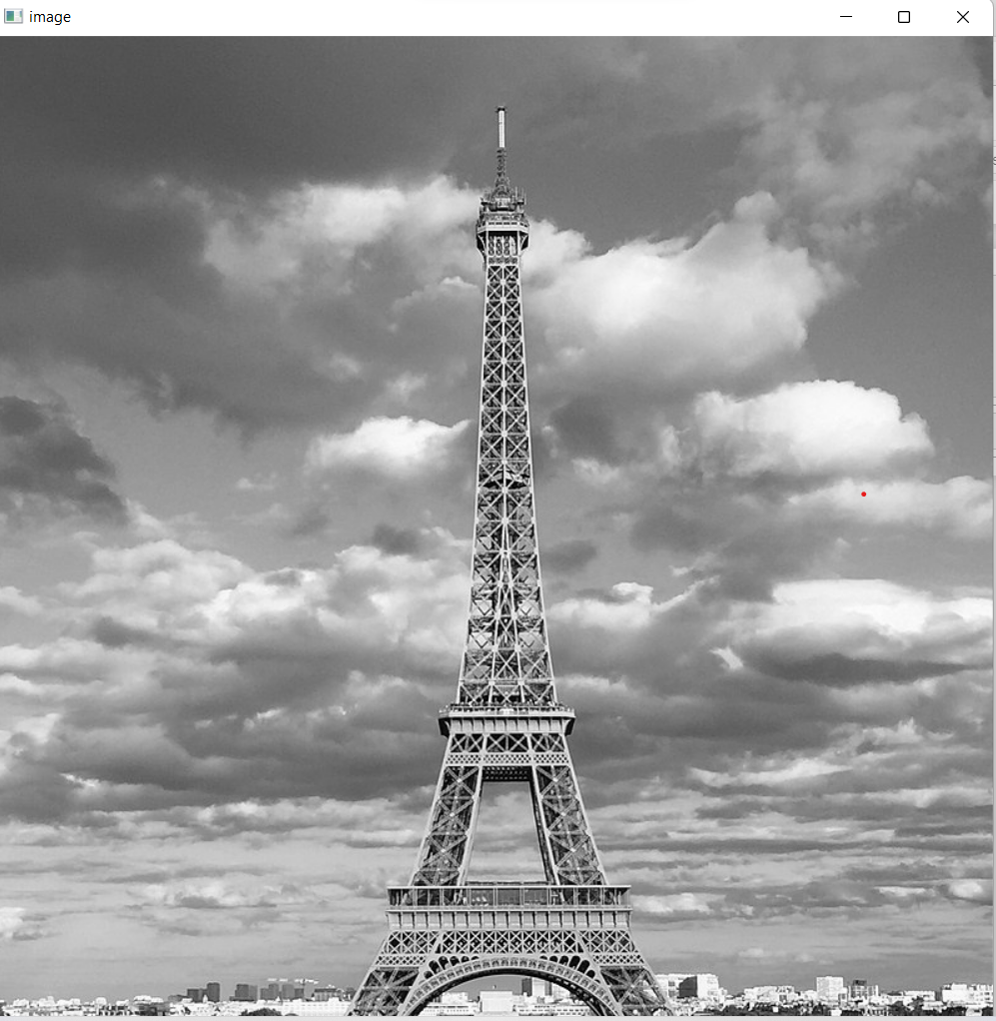

b)

import cv2

import numpy as np

path = r'D:\IP\images\paris1.jpg'

image=cv2.imread(r'D:\IP\images\paris1.jpg')

cv2.imshow("original",image)

Intensity_Matrix=np.ones(image.shape,dtype="uint8")*60

brt_image=cv2.add(image,Intensity_Matrix)

cv2.imshow("Bright",brt_image)

dark_image=cv2.subtract(image,Intensity_Matrix)

cv2.imshow("dark",dark_image)

cv2.waitKey(0)

print(Intensity_Matrix)

OUTPUT:

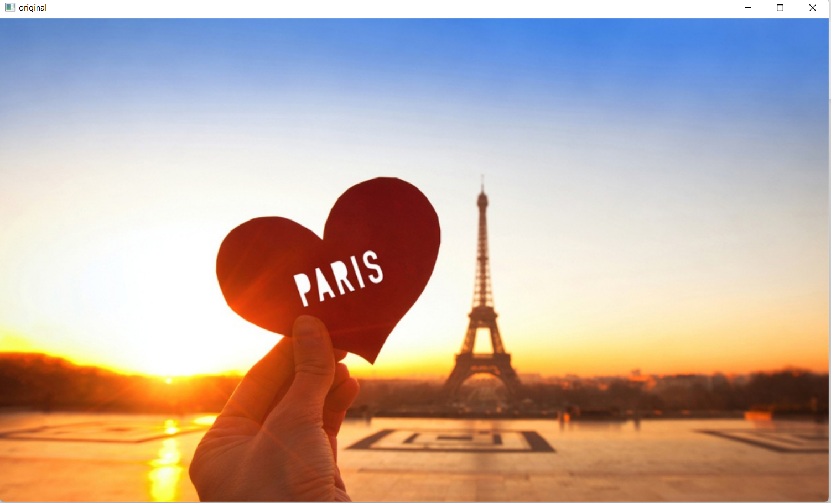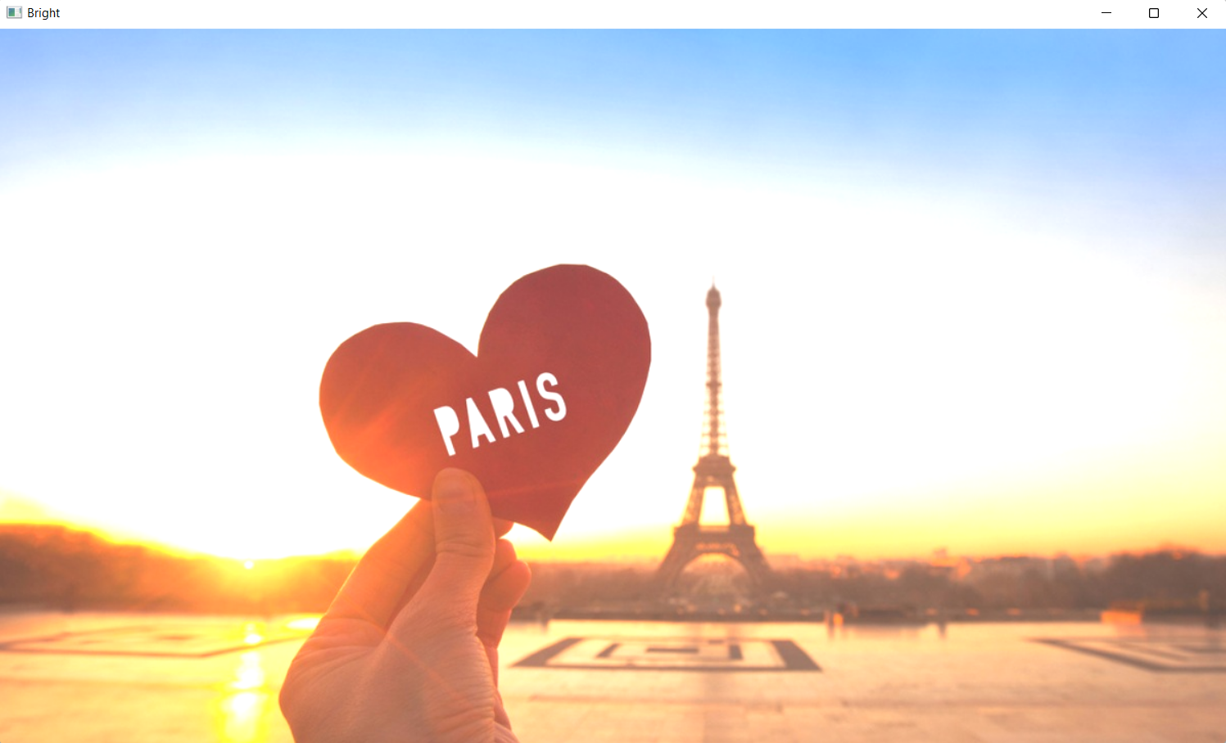

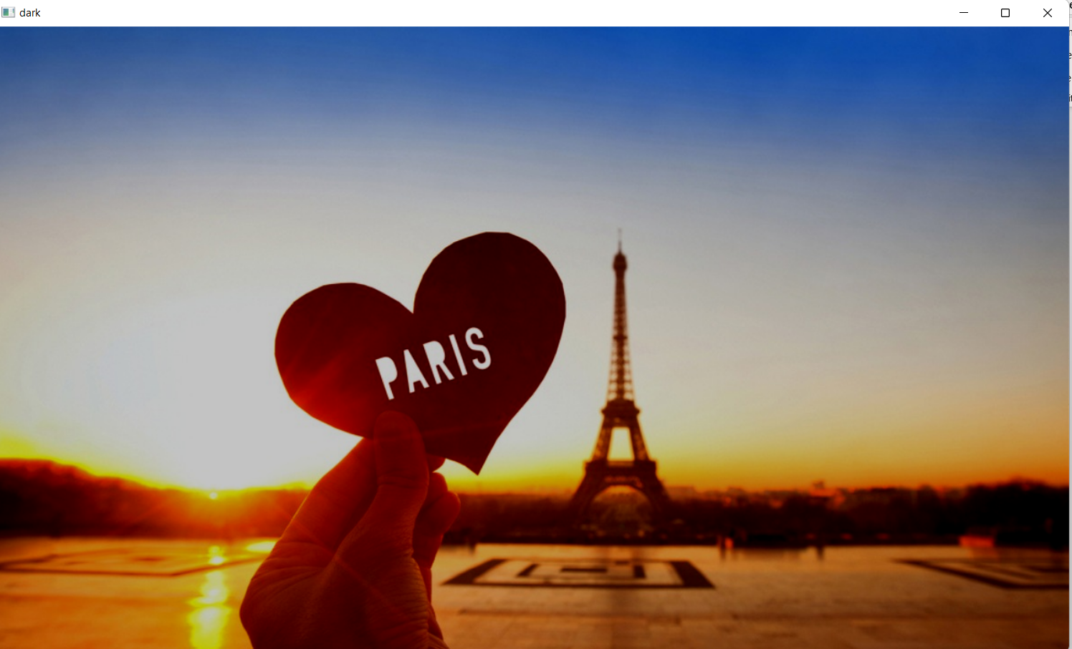

c)

import cv2

path = r'D:\IP\images\paris1.jpg'

image=cv2.imread(r'D:\IP\images\paris1.jpg')

cv2.imshow("original",image)

b,g,r=cv2.split(image)

cv2.imshow("Blue",b)

cv2.imshow("Green",g)

cv2.imshow("Red",r)

cv2.waitKey(0)

OUTPUT:

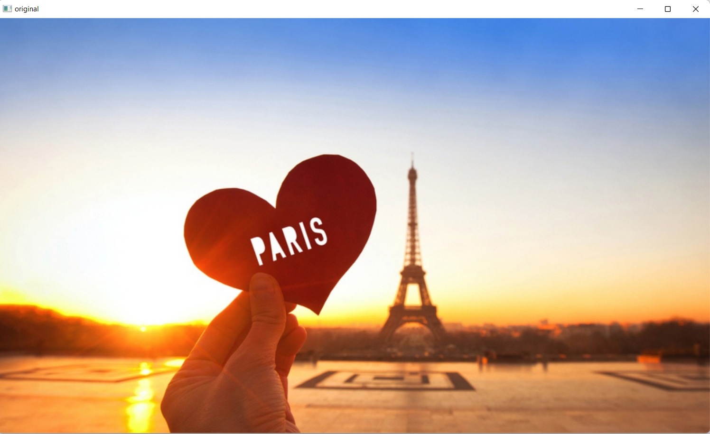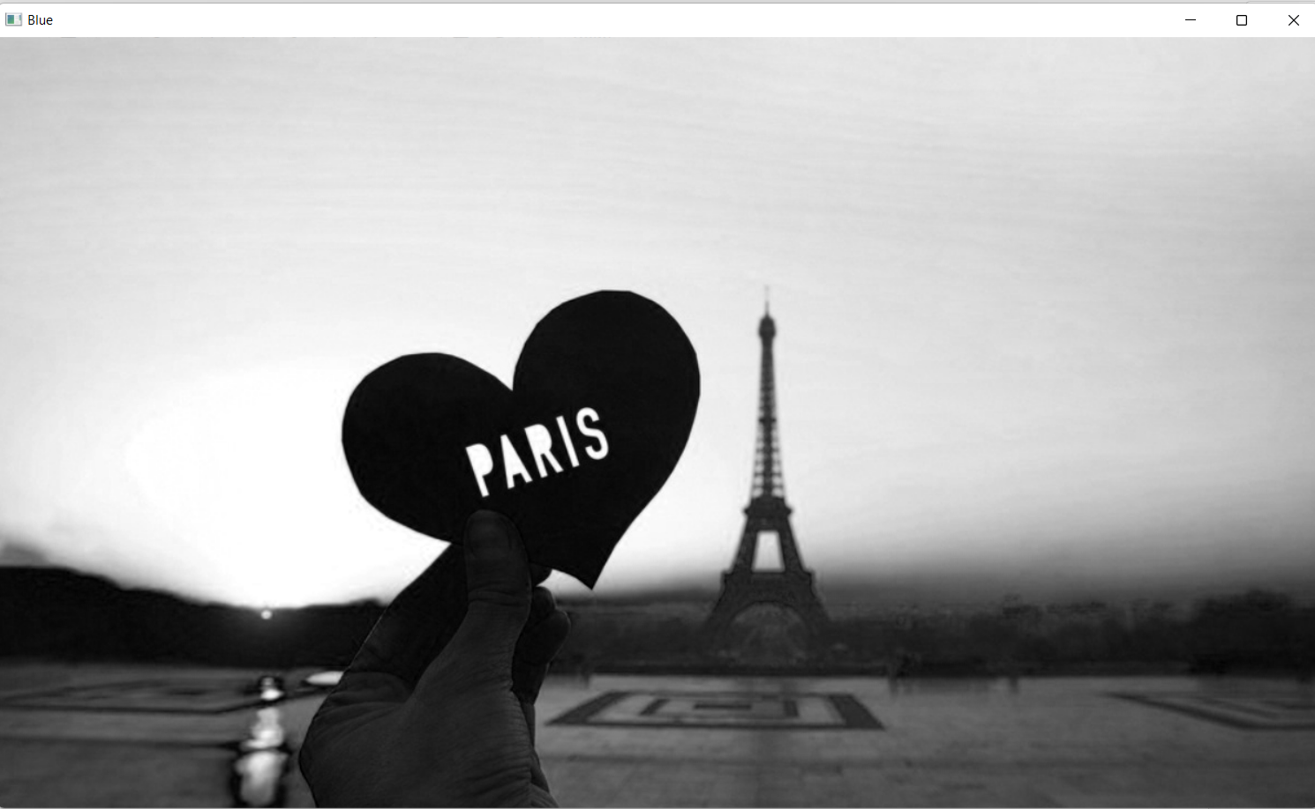

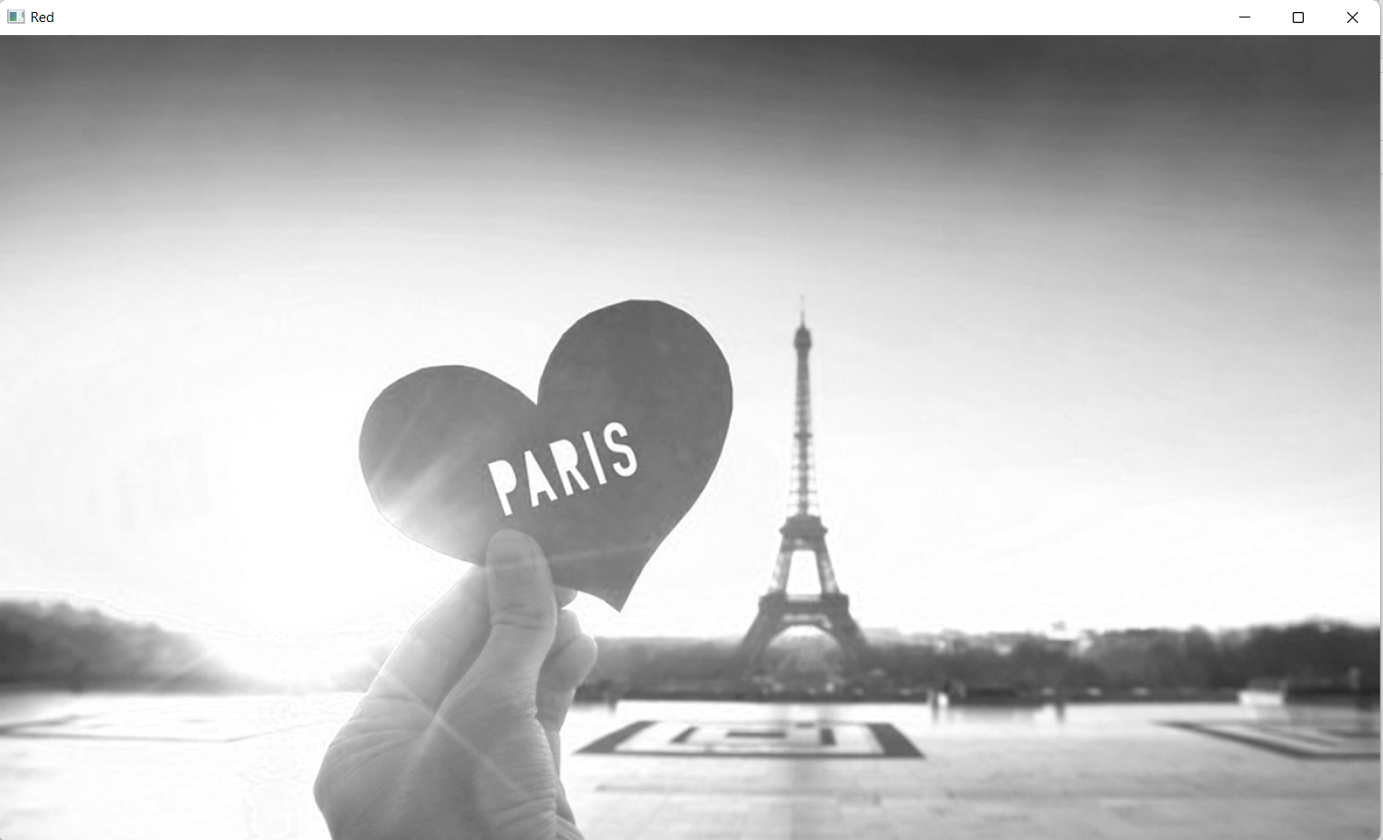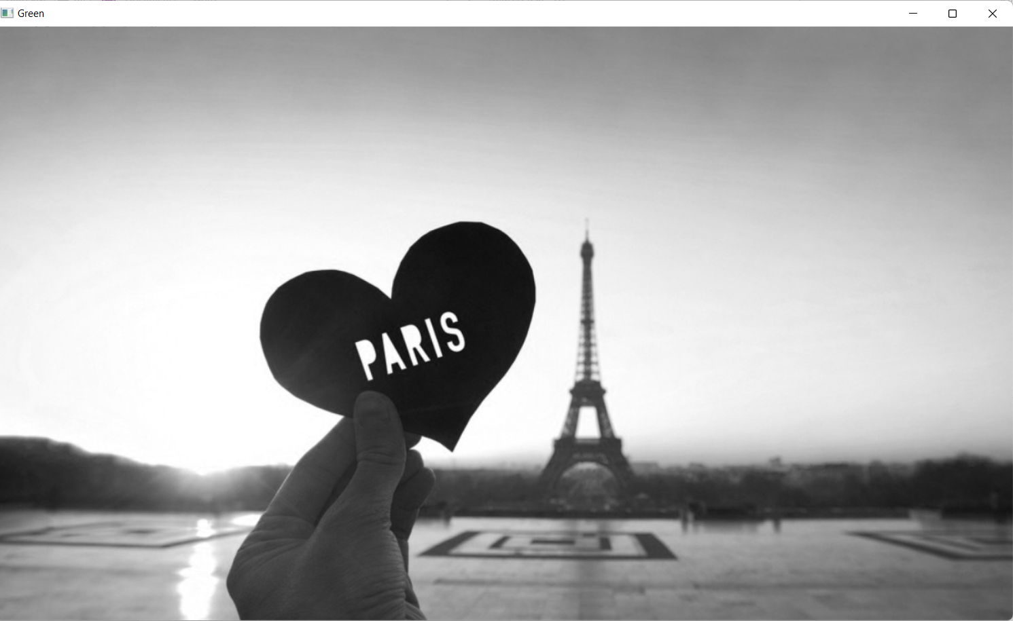

d)

import cv2

import numpy as np

image = cv2.imread(r"D:\IP\images\paris.jpg")

cv2.imshow('Original Image',image)

down_width=100

down_height=100

down_points=(down_width , down_height)

resized_down=cv2.resize(image,down_points,interpolation=cv2.INTER_LINEAR)

up_width=200

up_height=100

up_points=(up_width , up_height)

resized_up=cv2.resize(image,up_points,interpolation=cv2.INTER_LINEAR)

cv2.imshow('Resized Down by defining height and width',resized_down)

cv2.waitKey()

cv2.imshow('Resized Up by defining height and width',resized_down)

cv2.waitKey()

cv2.destroyAllWindows()

OUTPUT:

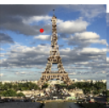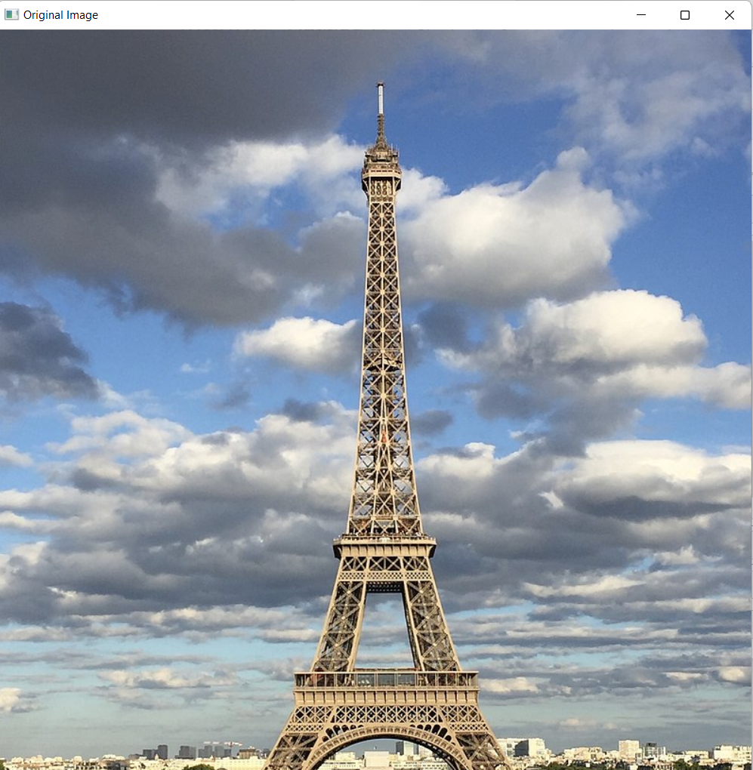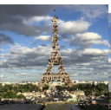

e)

import cv2

import imutils

path = r'D:\IP\images\paris.jpg'

img=cv2.imread(r"D:\IP\images\paris.jpg",cv2.IMREAD_COLOR)

rotate_img=imutils.rotate(img,angle=60)

cv2.imshow("Original",img)

cv2.imshow("Rotated",rotate_img)

cv2.waitKey(0)

OUTPUT:

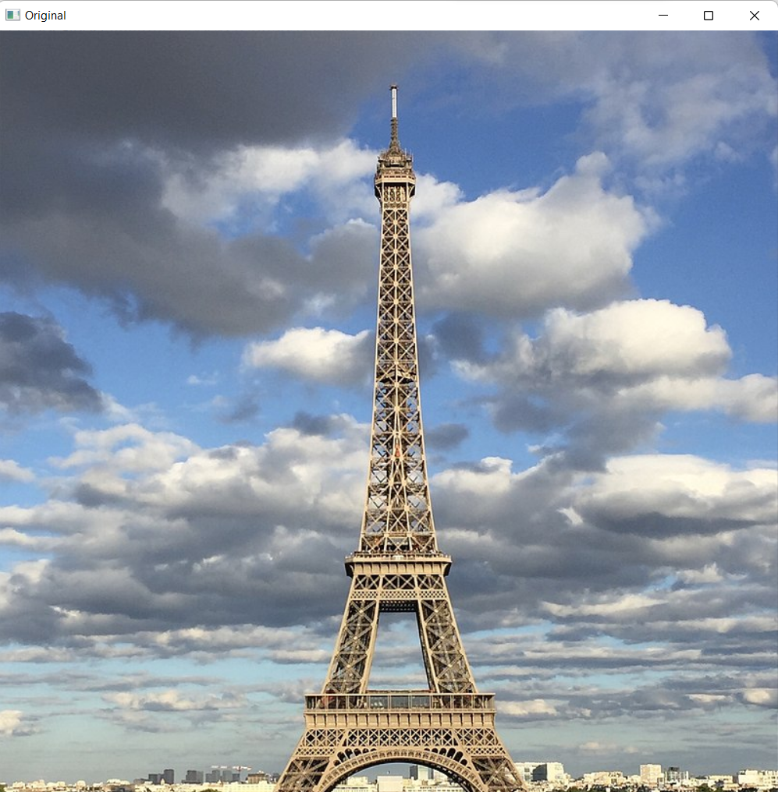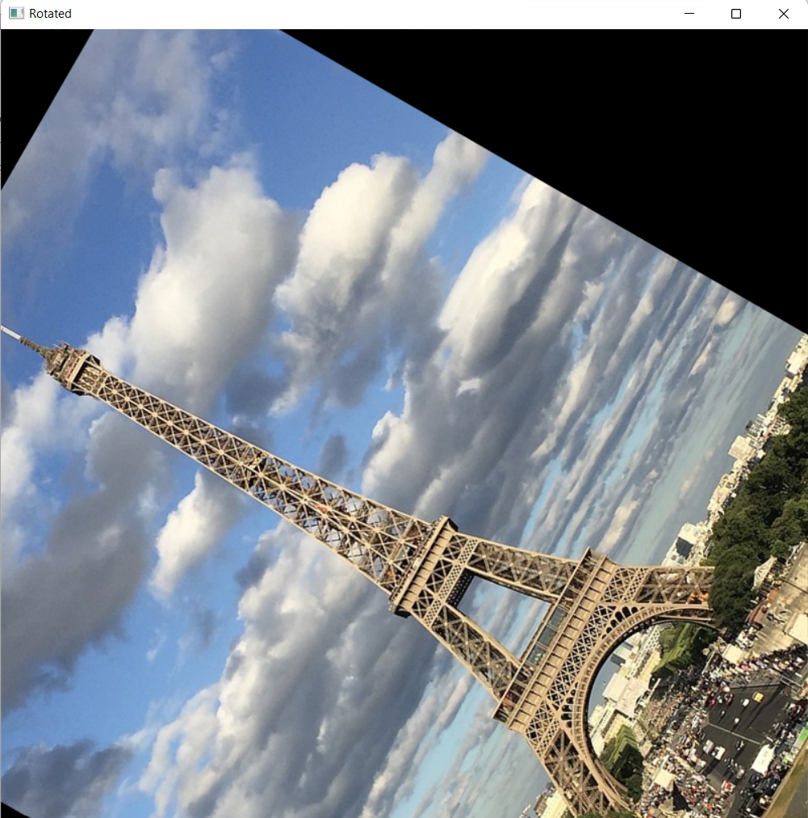

f)

import cv2

import numpy as np

path = r'D:\IP\images\paris.jpg'

img=cv2.imread(r"D:\IP\images\paris.jpg",cv2.IMREAD_COLOR)

height, width=img.shape[:2]

quater_height,quater_width = height/4, width/4

T= np.float32([[1,0,quater_width],[0,1,quater_height]])

img_translation=cv2.warpAffine(img,T,(width,height))

cv2.imshow("Originalimage",img)

cv2.imshow('Translation',img_translation)

cv2.waitKey()

cv2.destroyAllWindows()

OUTPUT:

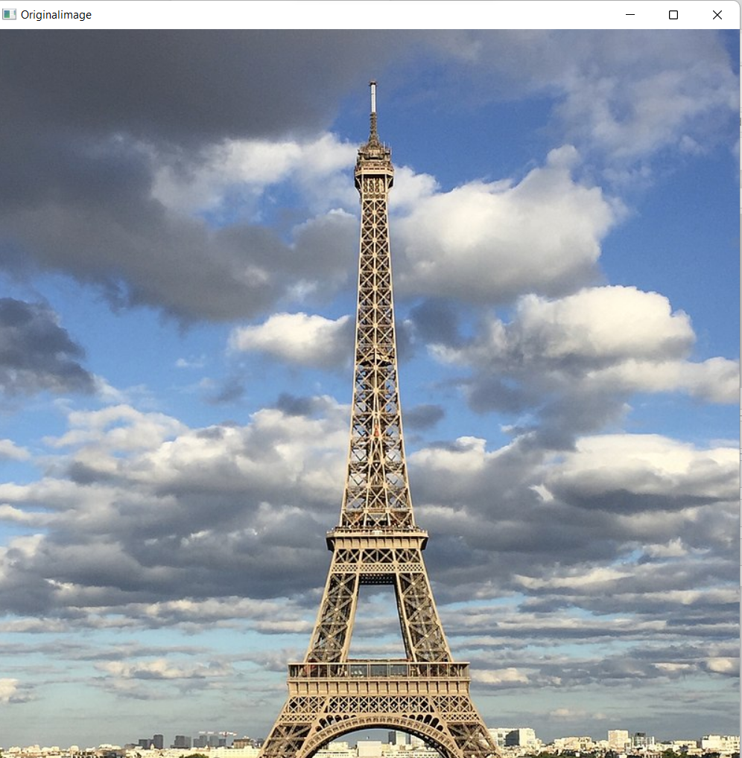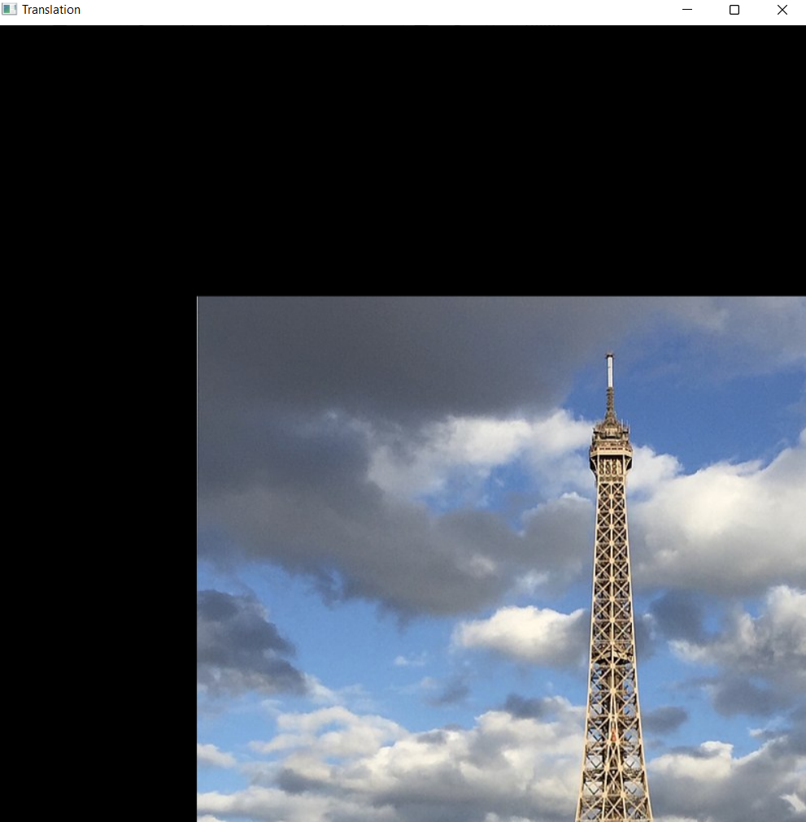

2)Write a python program using open CV library and perform basic image processing

operations(Arithmetic and logical).

RegNo:2117104

Date:11-08-2022--------------------------------------------------------------------------------------------------------------------------------------